

**Service of the Word, Sunday, October 18, 2020**

### 20th Sunday after Pentecost

**The Lutheran Church of the Redeemer, Ramsey, NJ**

**Prelude**

**WELCOME**

**Gathering**

The Holy Spirit calls us together as the people of God.

**Confession and Forgiveness**

Blessed be the holy Trinity, ☩ one God,

who creates, redeems, and sustains us and all of creation.

**Amen.**

Let us confess our sin in the presence of God and of one another.

*Silence is kept for reflection.*

Faithful God,

**have mercy on us.**

**We confess that we are captive to sin**

**and cannot free ourselves.**

**We turn from your loving embrace**

**and go our own ways.**

**We pass judgment on one another**

**before examining ourselves.**

**We place our own needs before those of our neighbors.**

**We keep your gift of salvation to ourselves.**

**Make us humble, cast away our transgressions,**

**and turn us again to life in you**

**through Jesus Christ, our Savior and Lord. Amen.**

God hears the cries of all who call out in need,

and through his death and resurrection,

Christ has made us his own.

Hear the truth that God proclaims:

Your sins are forgiven in the name of ☩ Jesus Christ.

Led by the Holy Spirit, live in freedom and newness

to do God’s work in the world.

**Amen.**

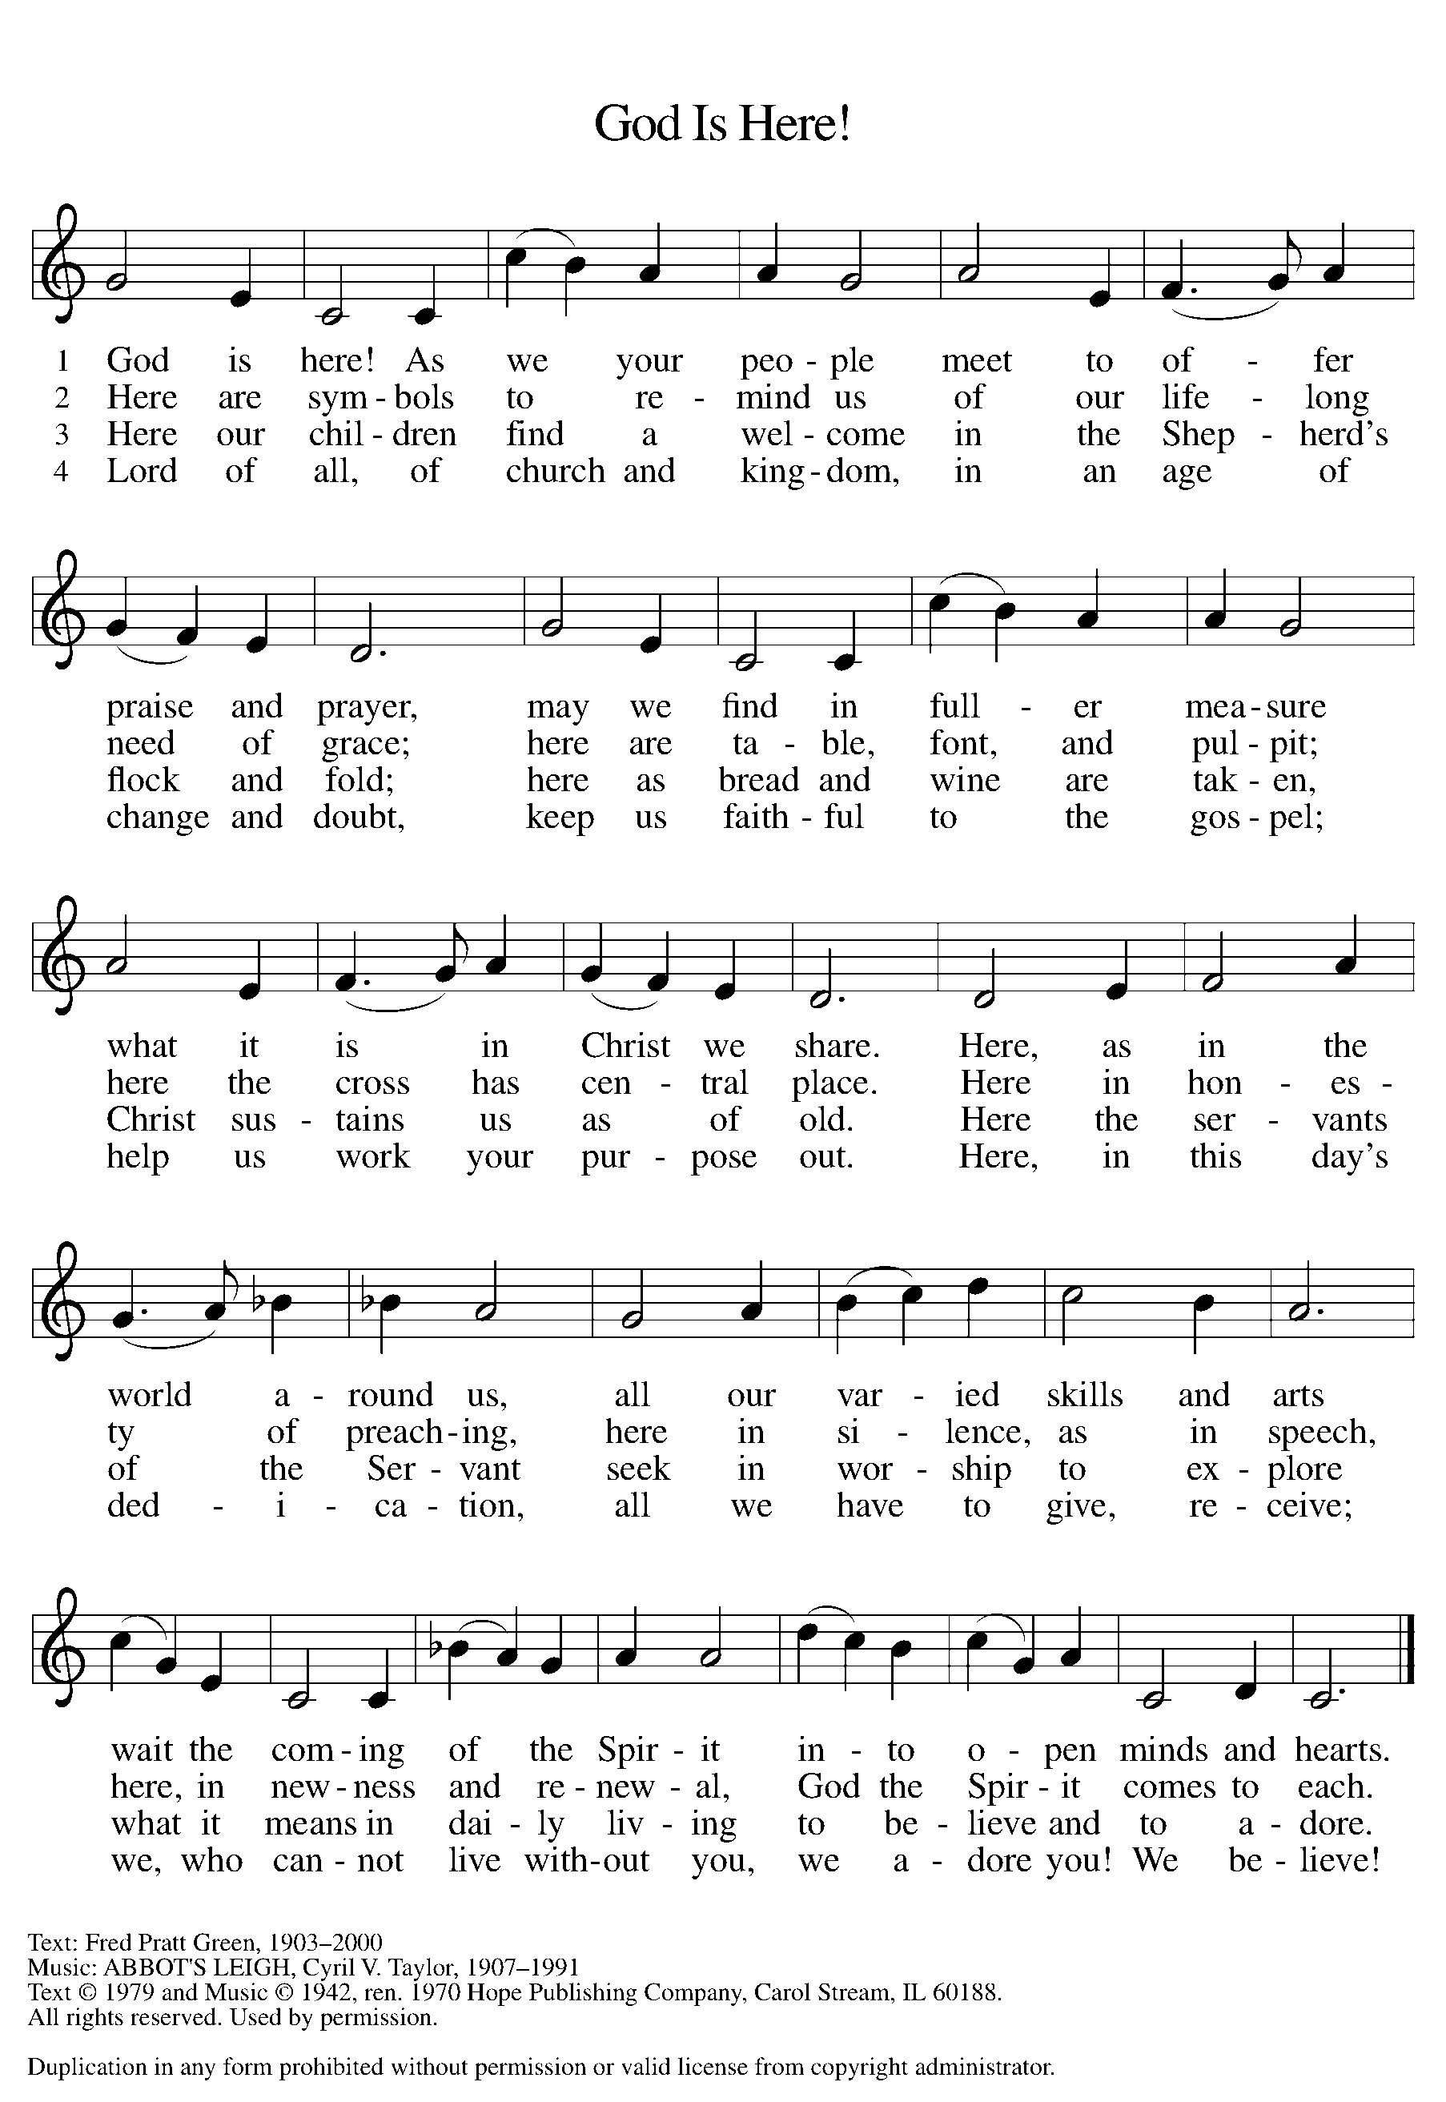

**Greeting**

The grace of our Lord Jesus Christ, the love of God,

and the communion of the Holy Spirit be with you all.

**And also with you.**

**GLORIA**

**Prayer of the Day**

Let us pray.

Sovereign God raise your throne in our hearts. Created by you, let us live in your image; created for you, let us act for your glory; redeemed by you, let us give you what is yours, through Jesus Christ, our Savior and Lord.

**Amen.**

### First Reading: Isaiah 45:1-7

A reading from Isaiah.

1Thus says the Lord to his anointed, to Cyrus,  
  whose right hand I have grasped  
 to subdue nations before him  
  and strip kings of their robes,  
 to open doors before him—  
  and the gates shall not be closed:  
 2I will go before you  
  and level the mountains,  
 I will break in pieces the doors of bronze  
  and cut through the bars of iron,  
 3I will give you the treasures of darkness  
  and riches hidden in secret places,  
 so that you may know that it is I, the Lord,  
  the God of Israel, who call you by your name.  
 4For the sake of my servant Jacob,  
  and Israel my chosen,  
 I call you by your name,  
  I surname you, though you do not know me.  
 5I am the Lord, and there is no other;  
  besides me there is no god.  
  I arm you, though you do not know me,  
 6so that they may know, from the rising of the sun  
  and from the west, that there is no one besides me;  
  I am the Lord, and there is no other.  
 7I form light and create darkness,  
  I make weal and create woe;  
  I the Lord do all these things.

The word of the Lord.

**Thanks be to God.**

### PSALM: Psalm 96:1-13

### 

1Sing to the Lord a new song;  
  sing to the Lord, all the earth.

2**Sing to the Lord, bless the name of the Lord;**  
  **proclaim God’s salvation from day to day.**  
 3Declare God’s glory among the nations  
  and God’s wonders among all peoples.  
 4**For great is the Lord and greatly to be praised,**  
  **more to be feared than all gods.**   
 5As for all the gods of the nations, they are but idols;  
  but you, O Lord, have made the heavens.  
 6**Majesty and magnificence are in your presence;**  
  **power and splendor are in your sanctuary.**  
 7Ascribe to the Lord, you families of the peoples,  
  ascribe to the Lord honor and power.  
 8**Ascribe to the Lord the honor due the holy name;**  
  **bring offerings and enter the courts of the Lord.**   
 9Worship the Lord in the beauty of holiness;  
  tremble before the Lord, all the earth.  
 10**Tell it out among the nations: “The Lord is king!**  
  **The one who made the world so firm that it cannot be moved will judge the peoples with equity.”**  
 11Let the heavens rejoice, and let the earth be glad;  
  let the sea thunder and all that is in it; let the field be joyful and all that is therein.  
 12**Then shall all the trees of the wood shout for joy at your coming, O Lord,**  
  **for you come to judge the earth.**  
 13You will judge the world with righteousness **R**

**Second Reading: 1 Thessalonians 1:1-10**

A reading from 1 Thessalonians.

1Paul, Silvanus, and Timothy,   
  To the church of the Thessalonians in God the Father and the Lord Jesus Christ:   
  Grace to you and peace.  
  
  2We always give thanks to God for all of you and mention you in our prayers, constantly 3remembering before our God and Father your work of faith and labor of love and steadfastness of hope in our Lord Jesus Christ. 4For we know, brothers and sisters beloved by God, that he has chosen you, 5because our message of the gospel came to you not in word only, but also in power and in the Holy Spirit and with full conviction; just as you know what kind of persons we proved to be among you for your sake. 6And you became imitators of us and of the Lord, for in spite of persecution you received the word with joy inspired by the Holy Spirit, 7so that you became an example to all the believers in Macedonia and in Achaia. 8For the word of the Lord has sounded forth from you not only in Macedonia and Achaia, but in every place your faith in God has become known, so that we have no need to speak about it. 9For the people of those regions report about us what kind of welcome we had among you, and how you turned to God from idols, to serve a living and true God, 10and to wait for his Son from heaven, whom he raised from the dead—Jesus, who rescues us from the wrath that is coming.

The word of the Lord.

**Thanks be to God.**

**Gospel Acclamation**

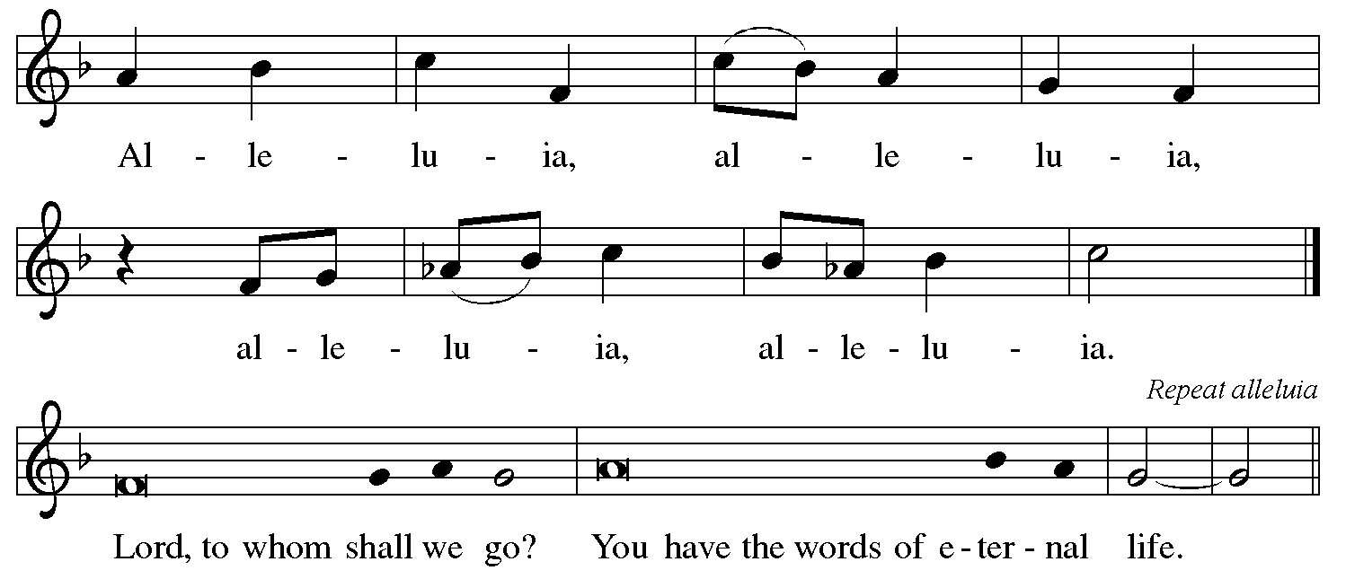

**Gospel: Matthew 22:15-22**

The holy gospel according to Matthew.

**Glory to you, O Lord.**

15Then the Pharisees went and plotted to entrap [Jesus] in what he said. 16So they sent their disciples to him, along with the Herodians, saying, “Teacher, we know that you are sincere, and teach the way of God in accordance with truth, and show deference to no one; for you do not regard people with partiality. 17Tell us, then, what you think. Is it lawful to pay taxes to the emperor, or not?” 18But Jesus, aware of their malice, said, “Why are you putting me to the test, you hypocrites? 19Show me the coin used for the tax.” And they brought him a denarius. 20Then he said to them, “Whose head is this, and whose title?” 21They answered, “The emperor’s.” Then he said to them, “Give therefore to the emperor the things that are the emperor’s, and to God the things that are God’s.” 22When they heard this, they were amazed; and they left him and went away.

The gospel of the Lord.

**Praise to you, O Christ.**

**Sermon**

**Hymn of the Day**



**Apostles’ Creed**

**I believe in God, the Father almighty,**

**creator of heaven and earth.**

**I believe in Jesus Christ, God’s only Son, our Lord,**

**who was conceived by the Holy Spirit,**

**born of the virgin Mary,**

**suffered under Pontius Pilate,**

**was crucified, died, and was buried;**

**he descended to the dead.**

**On the third day he rose again;**

**he ascended into heaven,**

**he is seated at the right hand of the Father,**

**and he will come to judge the living and the dead.**

**I believe in the Holy Spirit,**

**the holy catholic church,**

**the communion of saints,**

**the forgiveness of sins,**

**the resurrection of the body,**

**and the life everlasting. Amen.**

**Prayers of Intercession**

With confidence in God’s grace and mercy, let us pray for the church, the world, and all those in need.

*A brief silence.*

Gracious God, you call us by name and invite us to share your good news. Send your Holy Spirit among preachers, missionaries, and evangelists. We give thanks for the witness of your servant Luke, the evangelist, whom the church commemorates today. Lord, in your mercy,

**hear our prayer.**

God of praise, the heavens and all creation declare your salvation. From the rising of the sun to its setting, may the whole universe show forth your goodness. Raise up devoted stewards of all that you have made. Lord, in your mercy,

**hear our prayer.**

God of all, may your word of justice sound forth in every place. Restore divided nations and communities with reconciling truth. Lord, in your mercy,

**hear our prayer.**

God of light, we pray for those living with pain, illness, isolation, grief, anger, or doubt (especially). Join their voices in a new song, assuring them that you call them each by name. Lord, in your mercy,

**hear our prayer.**

God of truth, you show no partiality. May your spirit guide the work of justices, magistrates, court officials, and all vocations of the law, that your promise of restoration may be known. Lord, in your mercy,

**hear our prayer.**

*Here other intercessions may be offered.*

Living God, as you raised Jesus from the dead, so raise up those who have died in you (especially). We give thanks for their witness, confident of your rescuing welcome for all. Lord, in your mercy,

**hear our prayer.**

Listen as we call on you, O God, and enfold in your loving arms all for whom we pray, in the name of Jesus Christ our Lord.

**Amen.**

**Peace**

The peace of Christ be with you always.

**And also with you.**

**THANKSGIVING FOR GOD’S GIFTS**

**Offering Prayer**

Let us pray.

**Blessed are you, O God, maker of all things. Through your goodness you have blessed us with these gifts: our selves, our time, and our possessions. Use us, and what we have gathered, in feeding the world with your love, through the one who gave himself for us, Jesus Christ, our Savior and Lord.**

**Amen.**

**Thanksgiving for the Word**

We give thanks to God this day for His holy Word, dwelling among us.

Let us pray.

Praise and thanks to you, holy God, for by your Word you made all things: you spoke light into darkness, called forth beauty from chaos, and brought life into being. For your Word of life, O God,

**we give you thanks and praise.**

By your Word you called your people Israel to tell of your wonderful gifts: freedom from captivity, water on the desert journey, a pathway home from exile, wisdom for life with you. For your Word of life, O God,

**we give you thanks and praise.**

Through Jesus, your Word made flesh, you speak to us and call us to witness: forgiveness through the cross, life to those entombed by death, the way of your self-giving love. For your Word of life, O God,

**we give you thanks and praise.**

Send your Spirit of truth, O God; rekindle your gifts within us: renew our faith, increase our hope, and deepen our love, for the sake of a world in need. Faithful to your Word, O God, draw near to all who call on you; through Jesus Christ, our Savior and Lord, to whom, with you and the Holy Spirit, be honor and glory forever.

**Amen.**

**Lord’s Prayer**

Gathered into one by the Holy Spirit, let us pray as Jesus taught us.

**Our Father, who art in heaven,**

**hallowed be thy name,**

**thy kingdom come,**

**thy will be done,**

**on earth as it is in heaven.**

**Give us this day our daily bread;**

**and forgive us our trespasses,**

**as we forgive those**

**who trespass against us;**

**and lead us not into temptation,**

**but deliver us from evil.**

**For thine is the kingdom,**

**and the power, and the glory,**

**forever and ever. Amen.**

**Announcements**

### Blessing

Mothering God,

Father, ☩ Son, and Holy Spirit,

bless you and lead you into the way of truth and life.

**Amen.**

**Sending Song**



**Dismissal**

Go in peace. Remember the poor.

**Thanks be to God.**

**Postlude**

From sundaysandseasons.com.

Copyright © 2020 Augsburg Fortress. All rights reserved.

ONE LICENSE #A-727081